Network Simulation Through Radio Mobile and Cooja

Bright Kudzaishe Mahembe  
Department of Computer Science   
University of the Western Cape  
Robert Sobukwe Rd, Bellville Cape Town 7535  
3750046@myuwc.ac.za

*Abstract*— This project provides a detailed explanation of emulating an Internet of Things (IoT) network layer protocol. Network simulation tools including Radio Mobile and Cooja with the RPL and SDN controller were used to test the network connectivity on banks in Durban.

Keywords—Networking, Radio mobile, radiofrequency, cooja, SDN, RPL, spanning tree, IoT.

# Task

The individual project consists of emulating an IoT network layer protocol that could be used for routing the sensor readings collected at different locations of the city where data has been collected for different group project applications. A student has to implement the network with 2.4 and 3.6 GHz frequencies.

# Methodology

Bank branch location data in Durban was will be used to emulate an IoT network. This process includes obtaining the link budget between different bank branches through Radio mobile on 2.4 GHz and 3.5 GHz frequency networks.

The obtained link budgets will be used to develop a minimum spanning tree (MST) topology, a Backbone topology, and a Clustering topology of the remote bank branches in Durban.

Once the topologies are obtained, Cooja will be used with RPL and an SDN controller to simulate the network using bank branch coordinates.

# Implementation

## Data Collection

The first process in developing the IoT network layer protocol was the data collection phase. In this phase, google maps Places and Map elevation APIs were used to obtain the latitude, longitude, and elevation of each bank branch in Durban.

A total of 20 banks were obtained from the google maps API. Standard bank had the most branches across Durban with 4 different braches recorded.

## Network report

The collected bank branch data was used to create two networks in radio mobile. The first network created is a 2.4 GHz network of the using the bank collected data, the second network is a 3.6 GHz network created from the collected bank data. Figure 1 provides a visual illustration of the links obtained through both the 2.4 GHz and 3.6 GHz networks in Radio mobile respectively.

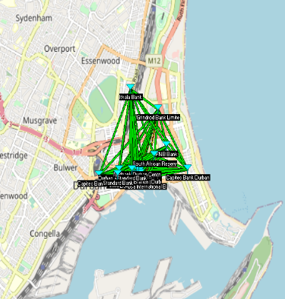 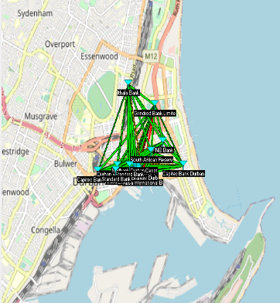

(2.4 GHz) (3.6 GHz)

Figure 1: Radio Mobile Networks.

## Dense Topology

The network report obtained from Radio mobile was used to develop a dense topology of the links between bank branches in Durban were each node number can be mapped to a specific bank branch. Figure 2 provides a visual illustration of the graph obtained from the 2.4 GHz and 3.6 GHz networks.

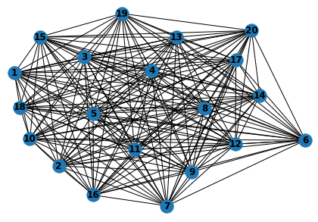 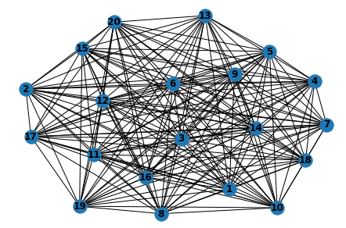

(2.4 GHz) (3.6 GHz)

Figure 2: Dense Topology.

## Sparse Topology

The dense topology was reduced through the link topology reduction algorithm. The results of the link topology reduction algorithm are presented in figure 3.

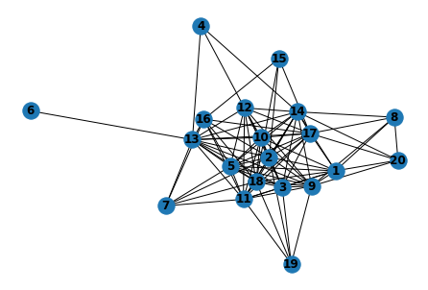 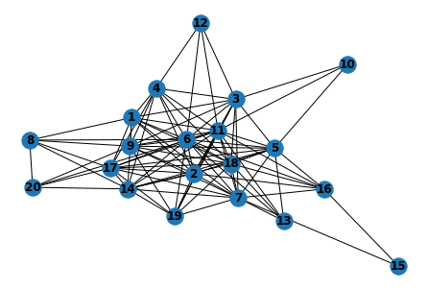

(2.4 GHz) (3.6 GHz)

Figure 3: Sparse Topology.

## Minimum Spanning tree topology

Three different minimum spanning tree (MST) algorithms were used to obtain MSTs of both the 2.4 GHz and 3.6 GHz sparse graphs respectively. The algorithms used to develop the MSTs include Kruskals MST algorithm, Prims MST algorithm and, Boruvka MST algorithm. A total of 3 MST’s were obtained for each frequency, figure 4 provides a visual illustration of the obtained MSTs.

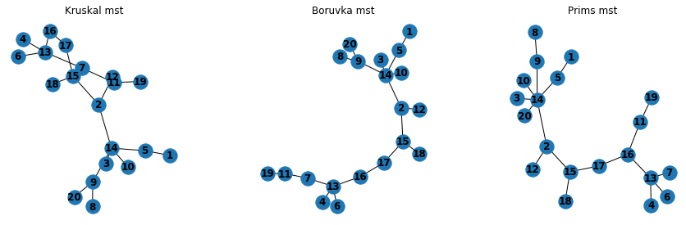

(2.4 GHz MST’s)

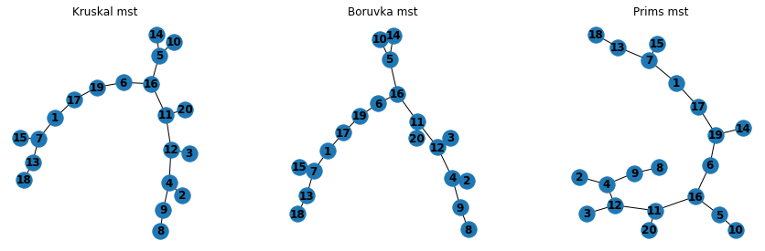

(3.6 GHz MST’s)

Figure 4: MST Topology.

## Backbone topology

The backbone algorithm topology obtained from the sparse topology consists of 2 stations or access points at nodes 1 and 2 from both the 2.4 GHz and 3.6 GHz frequency networks. However, the difference between the two network backbone topology structures is the number of nodes (bank branches) that are directly connected to the access point at node 1. The 3.6 GHz has 13 nodes that are connected to the access point at node 1 whilst in the 2.4 GHz network, only 10 nodes can directly connect to the access point at node 1.

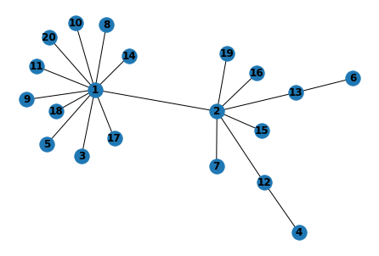 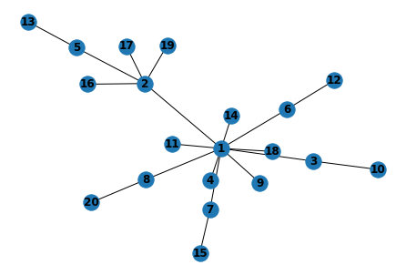

(2.4 GHz) (3.6 GHz)

Figure 5: Backbone Topology.

## Clustering Topology

Scikit-learn was used to cluster the sparse topology on the 2.4 GHz and 3.6 GHz network graphs. Each cluster is represented by a unique color. Both sparse topologies were clustered into three clusters however, the cluster groups between the 2.4 GHz and 3.6 GHz sparse topologies contained different nodes.

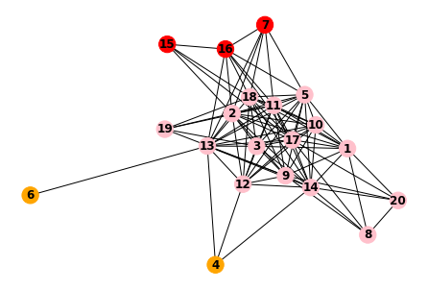 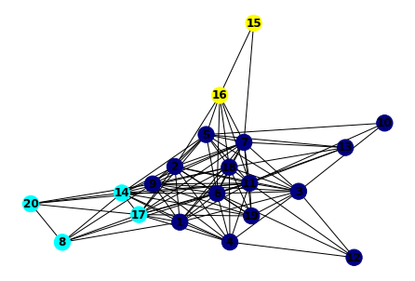

(2.4 GHz) (3.6 GHz)

Figure 6: Clustering Topology.

## Cooja simulation

The collected data coordinates were used to create a network that uses the Routing Protocol for Low-Power and Lossy Networks (RPL). The Sky mote firmware was used to create the nodes where each node represents a unique bank in Durban. Figure 7 is an image of the Cooja RPL simulation.

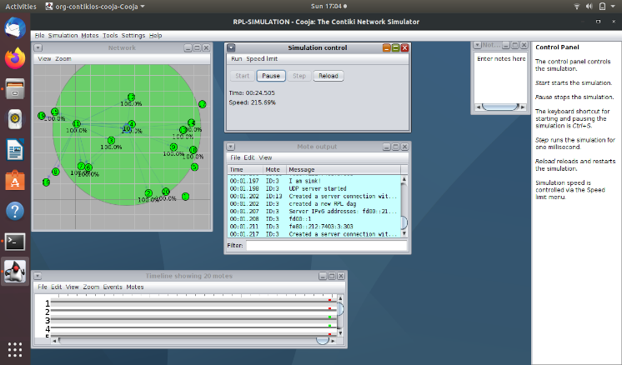

Figure 7: RPL Cooja simulation.

The collected data coordinates were also put through a second Cooja simulation this time with an SDN controller as illustrated in figure 8.

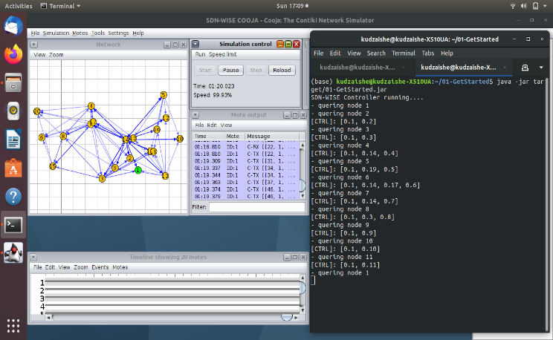

Figure 8: SDN Cooja simulation.

# Conclusion

When building a network, Radio mobile and Cooja are the ideal simulation tools. With Radio mobile you can get link budgets (network report) that would be used to develop dense topologies, sparse topologies, backbone topologies, and minimum spanning tree topologies to visualize the connectivity of your network. Once you are satisfied with the topologies, you can test the network in Cooja through the RPL and SDN controller to see how the network performs in a simulation.

For a detailed presentation on how to use the above tools please visit the links below.

Part 1: <https://youtu.be/MwiiX7cHugQ>

Part 2: <https://youtu.be/lgIyC2AknVc>